Revision History
Date | Version | Description | Author
16.03.2014 | 0.1 | First Implementation of SRS | Alp Kaan Erer, Can Şahin
18.03.2014 | 0.2 | MVC added | Alp Kaan Erer, Can Şahin, Fırat Emre Met

TABLE OF CONTENTS
Revision History 1
1 INTRODUCTION 3
1.1 Document overview 3
1.2 System overview 3
1.3 Abbreviations 3
1.4 References 3
1.5 Conventions 3
2 REQUIREMENTS 5
2.1 User Requirements Specification 5
2.2 System Architecture 7
2.3 Use Cases and Usage Scenarios 7
2.4 System Requirements Specification 9

INTRODUCTION

Document overview

This document presents the software requirements specifications of Block Breaker Game development project.

It includes:
- Functional and Non-Functional User Requirements.
- Use Case, UML Sequence and Activity Diagrams
- System Architecture
- Functional and Non-Functional System Requirements.

System overview
BlockBreaker is a game developed in Java where users play the game by breaking bricks with the help of a moving paddle and go through the levels.

Abbreviations

UML | Unified Modeling Language
SRS | Software Requirements Specifications

References

# | Document Identifier | Document Title
DOC1 | SDP | Software Development Plan of Block Breaker Game

Conventions
Requirements listed in this document are constructed according to the following structure:
Requirement Id
Requirement title
Requirement description

Requirement version

Example:
SRS-Breakout-000
Title of Breakout -000 requirement
Description of Breakout -000 requirement

Version of Breakout -000

Every system requirement id includes the id of the corresponding user requirement as a prefix.

Example:
SRS- Breakout -000.1
Title of Breakout -000.1 system requirement, which is related to the user requirement Breakout -000
Description of Breakout -000 requirement

Version of Breakout -000

REQUIREMENTS

User Requirements Specification

Functional Requirements:
SRS- BlockBreaker -001
Start Screen
Start screen shall present the highest score in the game in text format

V1.0

SRS- BlockBreaker -002
Start Screen
Start Screen shall present EXIT button that terminates the game

V1.0

SRS- BlockBreaker -003
Start Screen
Start screen shall present PLAY button that stars the game

V1.0

SRS- BlockBreaker -004
Game Play
The ball shall run and break bricks that it hits and gain points until it gets out of the border at the bottom side

V1.0

SRS- BlockBreaker -005
Game Play
Every one of the 10 broken bricks shall generate bonuses. They shall fall down in constant speed and shall be discarded when it goes down under the border if not caught by the paddle

V1.0

SRS- BlockBreaker -006
Game Play
Bonuses that are caught by the paddle will expand the paddle or duplicate the ball or shorten the paddle

V1.0

SRS- BlockBreaker -007
Game Play
The game levels shall be changed until the level 10, final level, after clearing out all the bricks in a particular level

V1.0

Non - Functional Requirements:

SRS- BlockBreaker -008
Game Play
The delay between the users’ keyboard input and its action should be in tolerance range for the user.

V1.0

System Architecture
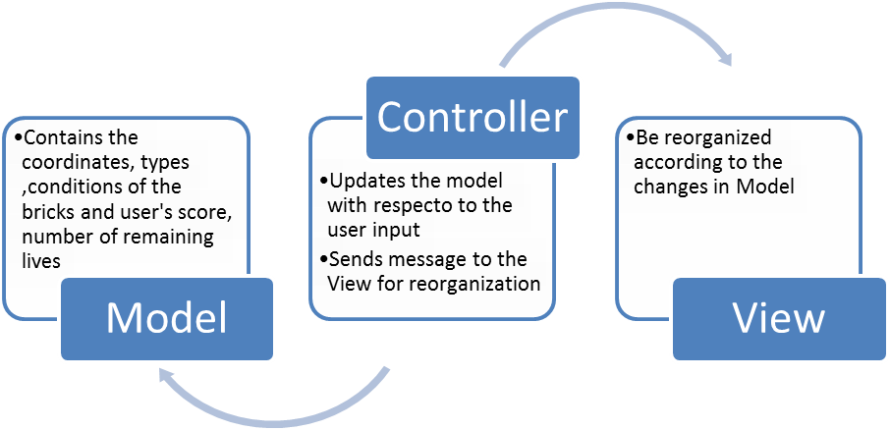

Use Cases and Usage Scenarios

Use Case Diagram:
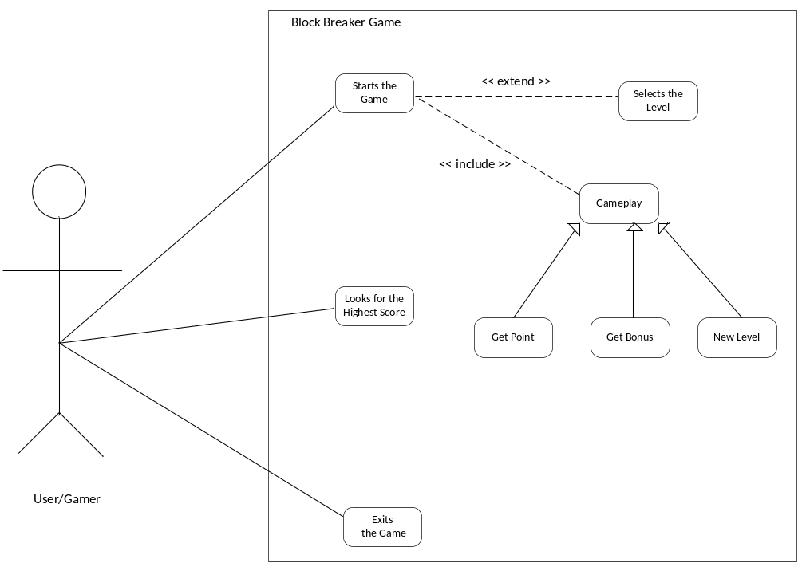

UML Sequence Diagram:
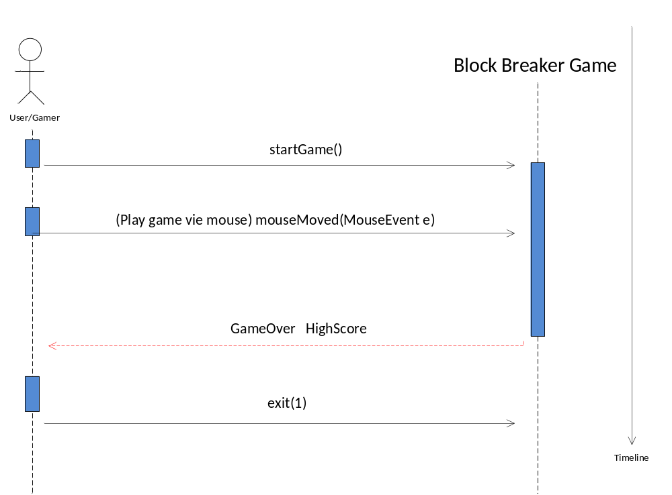

Activity Diagram:

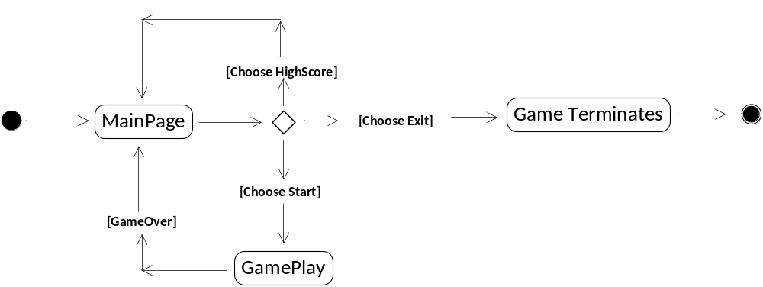

System Requirements Specification

Functional Requirements:
SRS- BlockBreaker -001.1
Start Screen
MainPage class reads the highest score data from the related file and puts its content in a field at the start screen.

V1.0

SRS- BlockBreaker -002.1
Start Screen
MainPage class will call exit(0) method.

V1.0

SRS- BlockBreaker -003.1
Start Screen
MainPage will initialize GamePlay class and make a call to the startGame() method

V1.0

SRS- BlockBreaker -004.1
Game Play
GamePlay class will keep the ball moving in a loop and checks the brick collisions and the ball’s coordinates in each loop
V1.0

SRS- BlockBreaker -004.2
Game Play
GamePlay class will remove the brick when there is a collision and the brick’s points will be added to user’s points

V1.0

SRS- BlockBreaker -004.3
Game Play
If the ball gets out of the borders number of lives remaining will checked and if remaining lives is zero the game will return to start screen if not, number of remaining lives will be decreased by one and level will restart

V1.0

SRS- BlockBreaker -005.1
Game Play
If the number of broken bricks is multiple of ten, a bonus will be generated.

V1.0

SRS- BlockBreaker -005.2
Game Play
If there is a generated bonus GamePlay class will move this bonus down in each loop and removes it if it is out of the border.

V1.0

SRS- BlockBreaker -006.1
Game Play
If the paddle collides with a bonus, according to its type the properties of the objects will be changed. There are three types of bonuses:
- Paddle expander
- Paddle shortener
- Ball duplicator

V1.0

SRS- BlockBreaker -007.1
Game Play
If the number of remaining bricks is zero data of the next level will be read from the file and bricks will be repositioned according to the data. Each brick data will include three types of information
- X Coordinate
- Y Coordinate
- Brick Type

V1.0

Non - Functional Requirements:

SRS- BlockBreaker -008.1
Game Play
The time between user’s keyboard button press and the action in the software must be short enough and tolerable for the user.

V1.0

